|  |
| --- |
| Heriot-Watt University |
| Design Report |
| Advanced Interaction Design F21AD |
|  |
| **Group 4: Sam Haley, Mary Holderby and Gordon Rennie** |
| **2/26/2019** |

|  |
| --- |
| [Type the abstract of the document here. The abstract is typically a short summary of the contents of the document. Type the abstract of the document here. The abstract is typically a short summary of the contents of the document.] |

# Background

This is a design report for our proposal to build an interactive device for people generally of age 65+ with limited mobility. The specified requirements that this device should provide are – the support of exercise, reminders to take medicine at correct times, communication of energy use and tips to decrease this, and a mechanism to request a small robot fetch small items of use within the home.

Forlizzi and Battarbee (2004) described three types of interactions that could be produced between a user and a product: (1) an interaction which focuses on the product and requires some thinking or cognitive action from the user; (2) an interaction which fits into a user’s routine without interrupting it, termed ‘fluent’; and (3) an interaction which develops a relationship between the user and the product. Our concept for this design attempts to provide an effortless interaction so that the user can proceed with the daily tasks described above, while useful link to the helpful robot. This has led the design to provide ‘button’ icons which depict the function which pressing that ‘button’ will provide, movement through screens both deeper and return through use of direction mapping ‘buttons’, while allowing changes to the interactive screen options in terms of medicine and exercises. The intention is to make the screen facilities describe themselves to the user so there is no requirement to puzzle out or find the manual to know how to use the screens.

# Stakeholder and Task Analysis

The stakeholders who will be inputting and updating information for this device and who will be interacting through this device include:

* Individual in home: primary user
* Medical staff: doctor, nurse, therapists
* Spouse, children, relatives: may or may not be present
* Emergency services: ambulance, fire personnel
* Maintenance staff: home, utilities, robot, interaction system

In addition to the needs of the user of the interaction device, there is a log-in screen which permits secure access of support staff such as medical staff and maintenance staff so that their interaction can proceed after formal identification. But to make lot-in for the user as seamless as possible, this screen will recognise and accept the primary user via a retina screen and having passed that check once a day, the primary user is ‘remembered’ so that they do not have to repeatedly log-in. Medical staff, once logged-in, can make amendments to medicine requirements and exercise options, while maintenance staff can utilise their log-in to test the ‘smart’ home devices and make amendments to energy devices. Emergency staff who log-in can check on which medicines the user has taken that day and scan exercise usage to facilitate their helping the user in an emergency. Family members who log-in may similarly check that the user is taking their medication correctly and may even wish to join in some of the exercises which the user has been given in the device.

The location in which this device will be used:

* Primary use within home which has ‘smart’ device monitoring of energy use
* Secondary use within medical offices of doctor, nurse, and variety of therapist locations

It is expected that the device may need knowledgeable updates from such individuals as the doctor or nurse who can make medication changes and a therapist who may have new exercises to propose that the user should attempt for continued physical improvement.

The details of the personae for whom the interaction device has been designed appear in the Appendix as Personae 7.2. The details of scenarios which have been used in this design appear in the Appendix as Scenarios 7.3.

# Requirements Analysis

Given the requirements listed in the Coursework specification – a mechanism to undertake exercise, reminders to take medication on time, information on home energy use with tips to minimise when desired, and a home robot to fetch items – plus requirements to support the stakeholders who want to support the primary user, screens were designed to support these functional areas. The functional areas were expanded with additional ‘supporting’ screens so that there was a complete provision of the function. Thus, the system is structured as:

* Log-in Screen
* ‘Home’ Screen
  + Medication
    - Medication Taken
      * Add Medication
      * Medication - Details
  + Home Energy
    - Weekly Energy Usage Chart
      * Energy in Use Now
      * Add Smart Appliances
  + Exercise
    - Available Exercises
      * Exercise Run-Through
    - Add Exercises
  + Robot
    - Ask robot to bring item
* Settings Screen

# Storyboard Design

Simplicity and consistency was a key concept when coming up with a design for how the application was laid out. For this reason the home page was designed to convey as much information about the function of the application with as little text as possible. Large buttons with a “3D” effect have been used throughout the application to make it clear what can be pressed. Isakovic *et al.* (2016) utilized a questionnaire to consider some design criteria which included use of buttons which relied on simple images to convey their purpose. Furthermore, they chose colours which were muted and a lack of too many functions per screen in their design of an interactive device for older diabetics. The UK Government has provided useful design tips for all services which anyone with a disability may require to use (Pun, 2016). The poster designed people who have limited mobility included a requirement for screen elements to have a large space around them while not crowding interactions. These are pointers which we have implemented in our design.

All pages of the application use the same basic layout with the time shown in the top right corner, a back button if applicable in the lower left corner, settings / edit in the lower right corner and the main features in the middle of the screen.

## Home Page

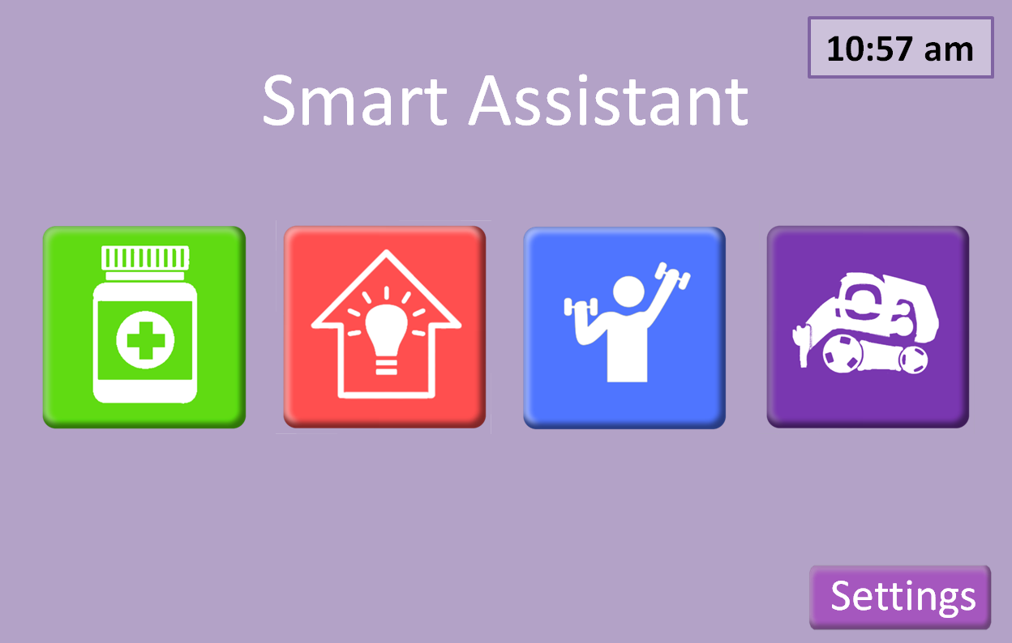

Colour coded buttons with “3d” effect to clearly indicate that they can be pressed

Figure 1 - shows the homepage for the app

The home screen has only five buttons each colour coded to ensure easy identification:

Green, medication button will take the user to the medication page of the application (see 2.4). This button will also pulse along with a chiming sound when it is time to take a given medication.

Red, energy/smart home button will take the user to energy page of the application ( see 2.3). This is where users can monitor their energy usage and get tips on how to become more energy efficient.

Blue, exercise button. Takes the user to a personalised exercise page with exercises tailored to the user’s specific needs. (see 2.2)

Purple “robot” button to get access to the smart homes assistant robot. (see add section)

Settings button, this allows the user to tailor the look and feel of the application to fit with their needs, such as colour blindness. (see add section )

## Medication

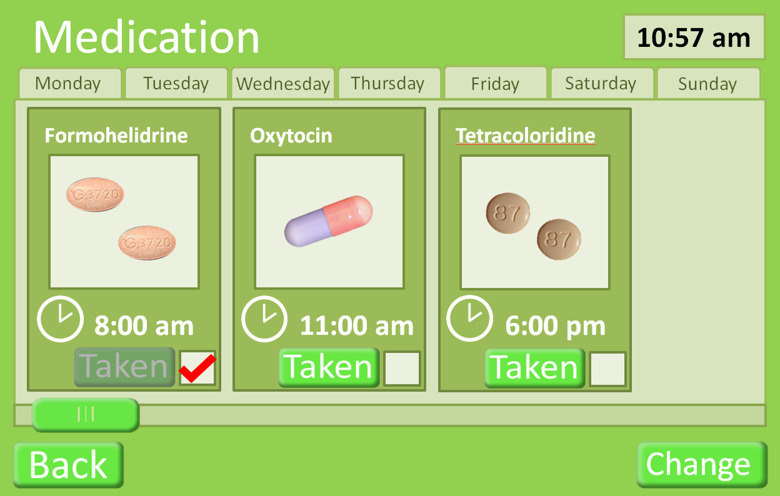

Press “taken” button when medication has been taken.

Press to change medication (see 2.4.1). This would be expected to be done with a doctor.

Can press the image of the medication to give more detail of the medication (see 2.4.2)

The medication page shows the user what medication should be taken on any given day, selected by the tabs at the top, it defaults to the current day. This page was designed to give only as much information as the user needs to take the medication. Hence, it shows: what the drug looks like and how many to take, the time it should be taken (if the user has not taken the medication by the set time the medication button on the home page will pulse and a chiming sound will be heard) and if the user has taken the medication yet that day.

### Add Medication

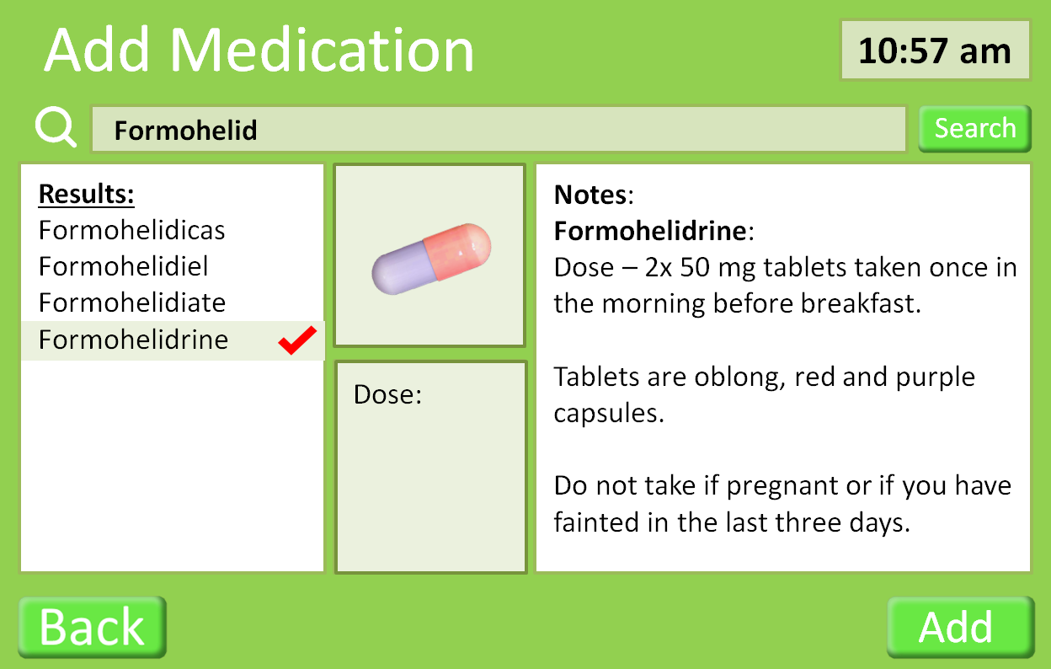

Drugs can be searched for in the database.

The correct drug can be selected from the results.

Details of the selected drug

The Add button adds the drug to the user’s medication.

This page is used in conjunction with a doctor. Drugs can be searched for and added into the users medication.

### Medication Details

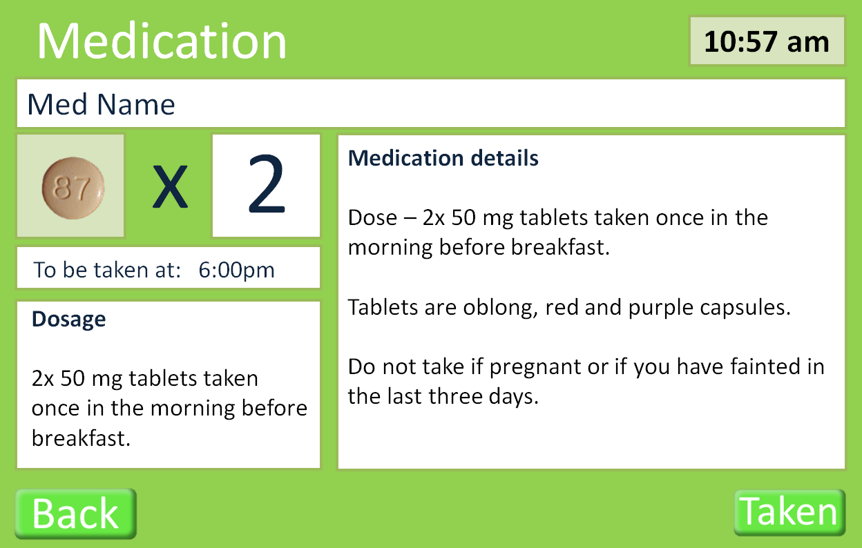

This page shows the full details of a specific medication.

## Energy page

This page will be updated

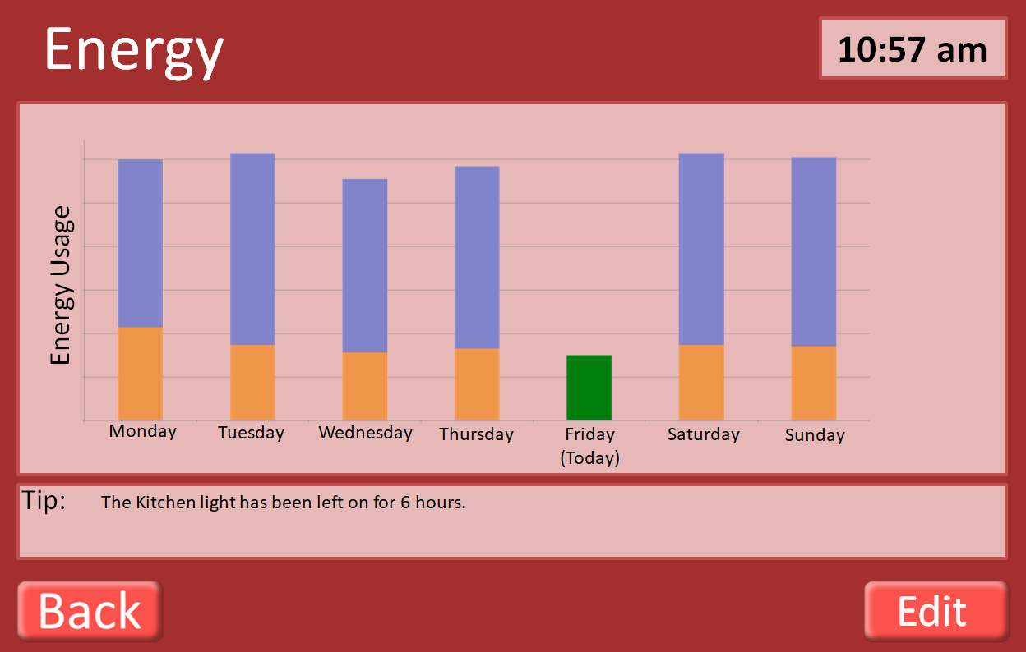

Total energy usage

Energy usage at 10:57am on given day

Edit button allows user to add smart devises to be tracked (see 2.3.1)

This page indicates the energy usage by the user over the past week. It also indicates how much energy had been used by the same time each day of the week. The application also tracks how long devises have been on and tries to prompt users to turn of devices that are not being used.

### Smart appliances

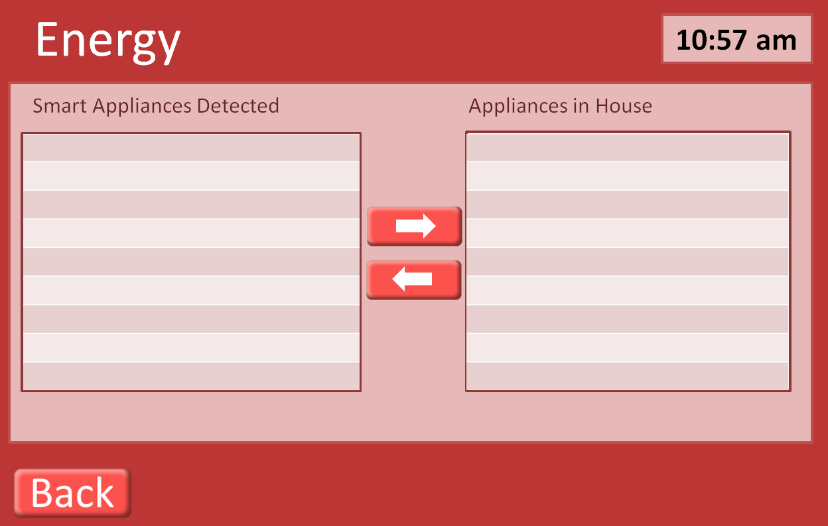

Use arrows to add remove devices from being tracked for energy usage.

This page is used to provide the user with the ability to add devices to be monitored by the application. Smart devices are automatically detected, shown in the Smart Appliances Detected, and can then be added to the home using the arrow buttons.

## Exercise page

The exercise page shows a list of exercises/activity’s that are tailored the user’s specific requirements.

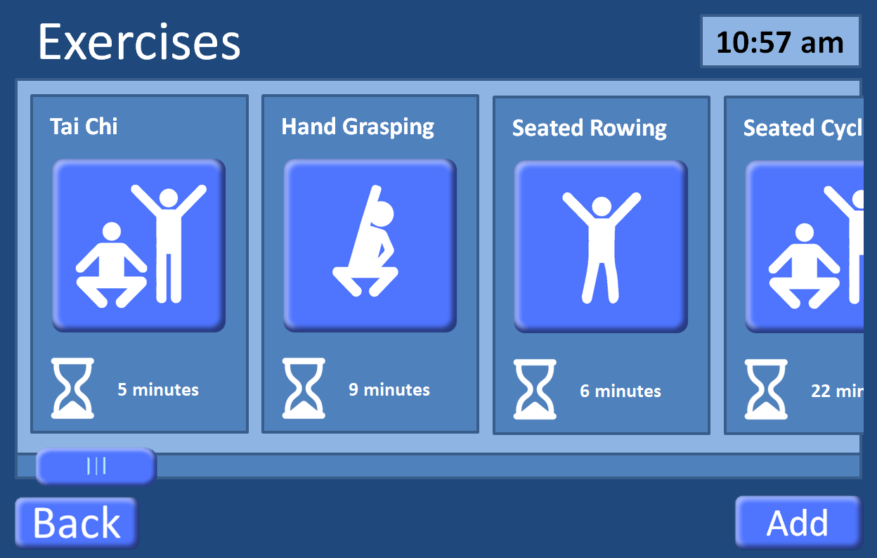

Press to add/ remove exercisers to the personalised list (see)

Indicates expected time needed for exercise

Press to start exercise

Back button takes user to previous page (home page 2.1)

Exercises hang off the end to indicate that the user can scroll. Scrolling can be done two ways: standard touchscreen hold and drag, or by using the scroll bar at the bottom.

### Add exercises

This image will be updated

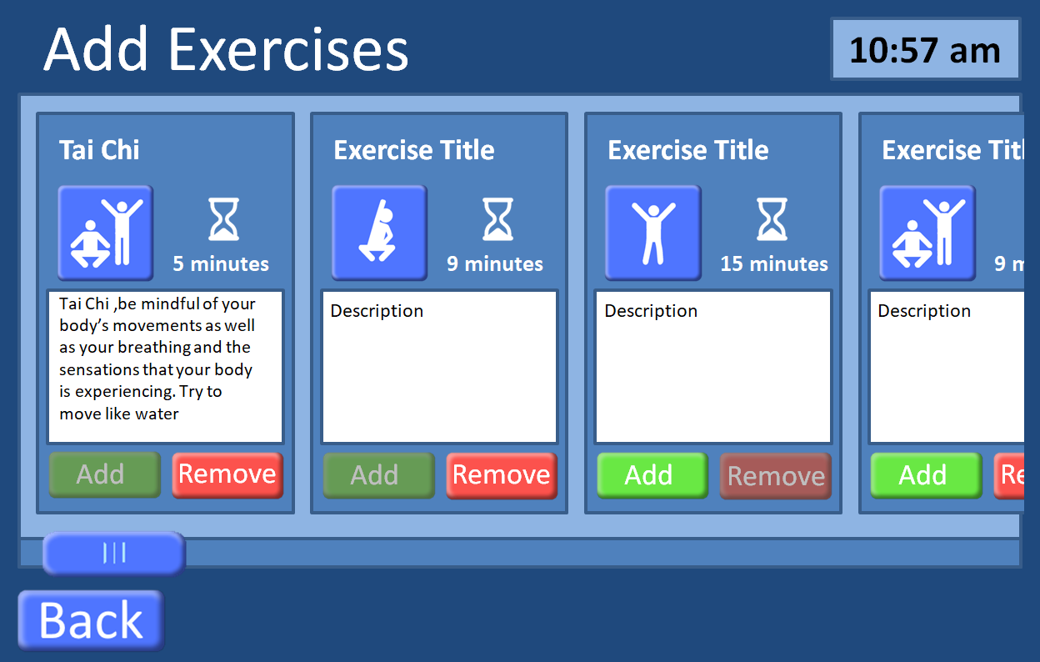

Press exercise button do a run though of the exercise to see if suitable (see 2.2.2).

Exercises can be added or removed based on recommendations from doctors and personal preferences of the user.

### Exercise run-through

Countdown timer showing how long a position must be held.

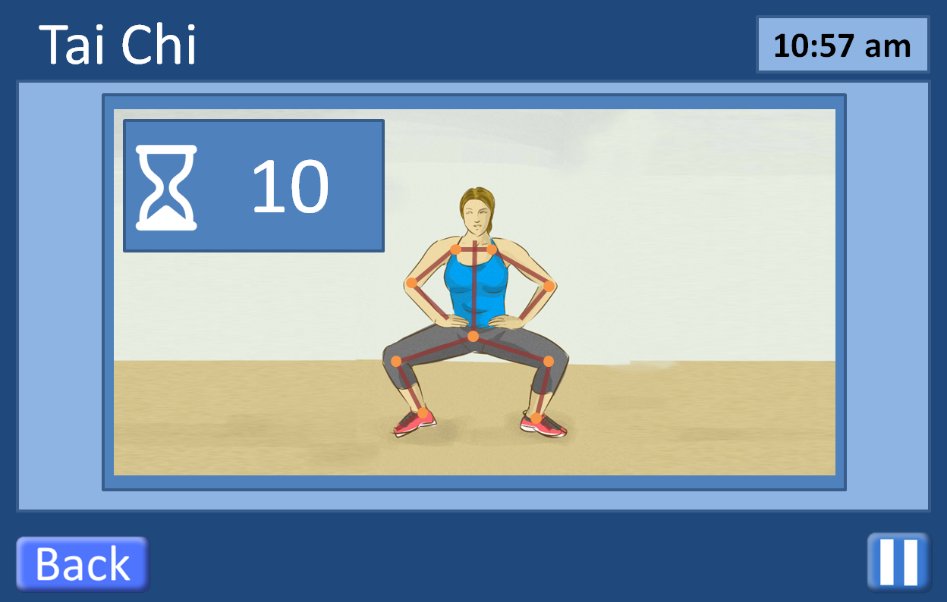

Overlay of user showing how closely they are matching the correct positions

Exercise can be paused at any time

Exercises work by having an animated video of a person doing the activity with an overlay of the user giving immediate feedback on how well the user is doing. Overlays may also appear on screen showing for instance how long the user must hold a certain position. The user can leave the exercise by pressing the back button which will take the user to the previous page (ether Add Exercise 2.2.1 or Exercises 2.2)

## Smart Robot (Cozmo)

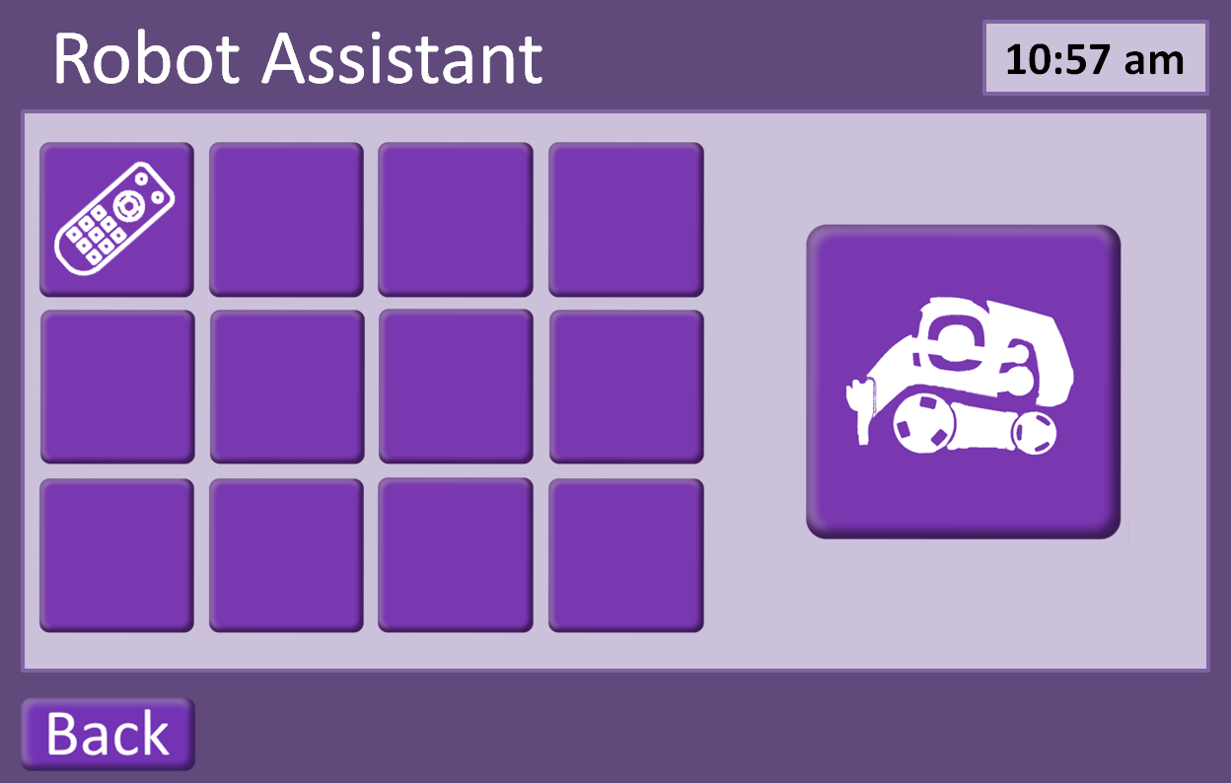

## Settings

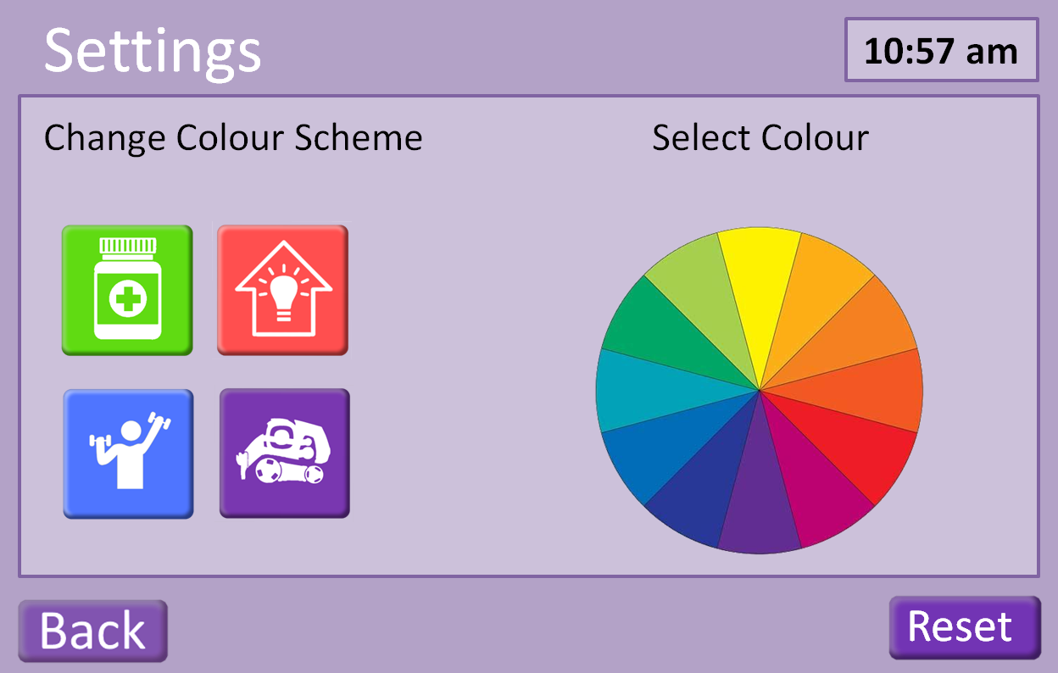

# Prototype Development

# Appendix

## Gantt Chart

## Personae

### Al –

Age : 66

: Widowed, 8 years

: 1 adult daughter, married with small children, lives in Australia

Health : Suffered first stroke six weeks ago

Al does not smoke, drinks moderately (2-3 beers a week, some weeks no drinks). A recreational cyclist, Al also likes to swim. Does not follow sports. Has been active with his church and has taught in Bible classes for ages 8 – 12, for a number of years. After retirement, he also began to work with the same age (8 – 12) group with a neighbourhood refugee support organization.

Worked 40+ years for an architectural/building firm. Initially worked as a mechanical engineer, but then as mechanical designer. He is in demand there as an occasional trainer for new employees in the mechanical design department. Because of his past design work, Al enjoys drawing and watercolour painting.

Consequences of stroke: minor speech impairment which has largely been overcome through therapy. Difficulty in walking and difficulty in assessing placement of objects/hands to place objects.

Was in a rehabilitation unit where some progress (mainly speech) was made. However, Al is in denial about the stroke and this means he is often distracted and/or depressed. 1 week ago he mixed up when to take his medication and this led to a minor medical reaction. This seems to have depressed him further. Al has moved to assisted living accommodation but he struggles with the results of the stroke in terms of being motivated to improve his health.

Next stages for improvement

: Al wants to be in his own home but to do this he needs to be able to

1. Walk through rooms, to bathroom, to kitchen. At present, he has difficulty doing this.

* Needed: Exercises to improve muscle strength, balance coordination, overall activity.

1. At present, in addition to walking problems, Al is often unable to grasp and control many home implements such as cooking utensils and has to rely on a ready-meal delivery system and also unable to draw or paint because of the lack of hand control. He finds the process to make his hands do as he wants very frustrating.

* Needed: Exercises to improve control and coordination of hands.

1. Take medication on time. Initial assessments have shown Al is depressed with his recent stroke and feels out of control over what matters to him. This in turn leads him to not act according to instructions, such as on medication. He presently has several types of medicine that need to be taken at specific times but despite labels on containers, Al failed to take one medicine correctly which led to some minor deterioration.

* Needed: A method that makes it easier for Al to take his medication at the right times.

1. Because Al has difficulty in walking, he needs extra assistance getting small, everyday items.

* Needed: A robot which could take instructions – ‘Bring me my glasses’, for example – would ease Al’s transition to being fully independent in his home again. Items that may be needed for a robot to fetch include: aforementioned glasses, pen and paper, mobile telephone.

If these four areas can see real improvement in Al’s ability to regain independence, it could make a positive difference to Al, who deeply misses feeling like a functioning adult with much to give to others.

*Nice to have:*

Given that Al has worked for a building company as a mechanical engineer and now designer, he would enjoy checking his use of heating and electricity of his environment. It would tie in with his past employment and give him an element of control over his life, something he feels he has lost with the stroke and its effects.

### Kitty -

Age : 78+

: Widowed, 23 years

: 3 adult children, married, 5 grandchildren

Health : Kitty uses a walker after a fall caused back damage.

Kitty gets less exercise than she once did and as a consequence her balance is deteriorating.

Kitty worked a cook for a hotel restaurant until retiring at age 59. She likes puttering around in a small garden and playing card games with the ladies at the local centre for pensioners.

Kitty is forgetful so can miss a dose of prescribed medication without reminders.

Next stages for improvement

: Kitty enjoys her independence as well as her social group at the local centre.

1. Kitty knows she should exercise more and accepts that if she doesn’t, she may lose the ability to visit the local centre.

* Needed: Exercises to improve muscle strength, balance coordination, overall activity.

1. Kitty enjoys when her grandchildren can come for a visit. She is sad when she cannot lift them to sit with her but she doesn’t handle weights very well.

* Needed: Exercises to improve arm tone through light weight lifting.

1. Take medication on time. Kitty is forgetful and often confuses her medication.

* Needed: A method that Kitty can easily follow to check off which tablets she has taken and which still need taken at what time would help her in this.

1. Kitty would enjoy extra assistance getting small, everyday items. She did have a home helper who came three times a week but the council had to cancel that as they no longer had the funds to pay the helper. Kitty misses the interaction.

* Needed: A robot might give Kitty an interaction in her home that would help give her social exercise.

*Nice to have:*

Kitty has said that she’d like to save a few pennies here and there and has wondered whether her home utility usage is a possible place to save a bit. Some tips along with a measure of how much she uses might help her.

## Scenarios

## Screenshots

## Logbook

## References

Baylor Scott & White Health, (2012, 30 July), Hands-On Health Care Discussions. Scrubbing In: Tips for encouraging the elderly to exercise [online]. Retrieved 2 February 2019, from <https://scrubbing.in/encouraging-the-elderly-to-exercise/>.

DailyCaring (2019). Seated Tai Chi for Seniors: 3 Simple Routines Improve Flexibility and Well-being [online]. Retrieved 29 January 2019, from <https://dailycaring.com/seated-tai-chi-for-seniors-3-simple-routines-improve-flexibility-and-well-being-video/>.

Forlizzi, J., and Battarbee, K., (2004). DIS ’04 Proceedings of the 5th conference on Designing Interactive systems: processes, practices, methods, and techniques. Cambridge, Massachusetts, USA, 1 – 4 August 2004. Pp. 261-268. Available at: doi.10/1145/1013115.1013152.

Isakovic, M., Sedlar, U., Volk, M. & Bester, J. (2016) Usability Pitfalls of Diabetes mHealth Apps for the Elderly. *Journal of Diabetes Research 9.* https://doi.org/10.1155/2016/1604609

Lomas-Vega, R., Obrero-Gaitan, E., Molina-Ortega, F., & Del-Pino-Casado, R. (2017). Tai Chi for Risk of Falls. A Meta-analysis. *Journal of American Geriatrics Society. 65*(9) 2037-2043. https://doi.org/10.1111/jgs.15008.

Myers, W. (2015, 21 May). Eleven Fun Ways Older Adults can get in Shape [online]. Retrieved 2 February 2019, from <https://www.everydayhealth.com/senior-health/fun-ways-seniors-can-get-in-shape.aspx>.

NHS (2019, 4 July). Physical Activity Guidelines for Older Adults [online]. Retrieved 29 January 2019, from <https://www.nhs.uk/live-well/exercise/physical-activity-guidelines-older-adults/>.

Pun, K., (2016). Do’s and Don’ts on Designing for Accessibility [online]. Gov.UK, Accessibility in Government. Available from: <https://accessibility.blog.gov.uk/2016/09/02/dos-and-donts-on-designing-for-accessibility/>.

Sandlund, E., & Norlander, T. (2000) The Effects of Tai Chi Chuan Relaxation and Exercise on Stress Responses and Well0Beeing: An Overview of Research. *International Journal of Stress Management. 7*(2) 139-149. <https://doi.org/10.1023/A:1009536319034>.